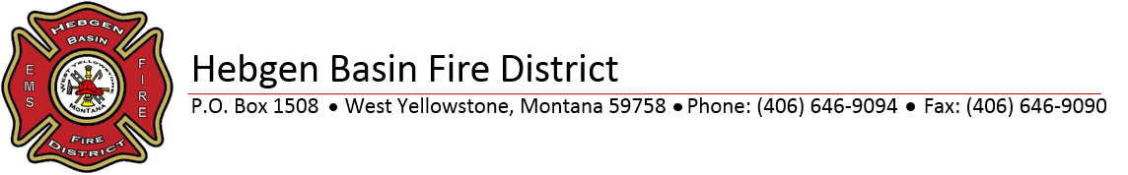

Special Board Meeting
June 30, 2020
12:00 P.M.
Station 1 West Yellowstone

Agenda
Roll Call
Public Comment for Items Not On Agenda
Approve Claims/Deposits End of Fiscal Year

